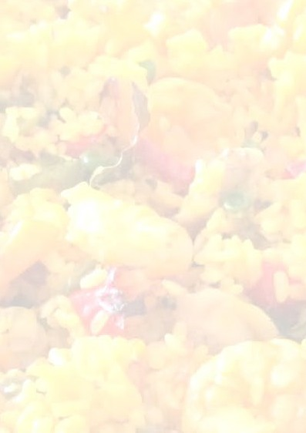
Changing Seasons Café

DRINKS MENU
Coffee: All premium Beraldo coffees have the choice of full cream, low fat, soy & almond milk
 | Regular - Large
Cappuccino - Beraldo Coffee served with milk dusted with Gluten free Chocolate powder | $4.50 - $6.00
Flat White - Beraldo Coffee served with milk | $4.50 - $6.00
Latte - Beraldo Coffee served with milk | $4.50 - $6.00
Piccolo Latte  Beraldo 30ml shot of coffee expresso served with milk | $3.50
Long Black  $5.50 (2 shots) - $4.00 (1 Shot) Coffee blend & hot water | $4.00 - $5.50
Short Black - 30ml shot served with perfect thick golden crema on  top | $3.50
Long Macchiato - Beraldo Coffee served with milk | $4.00
Short Macchiato - Single shot of espresso served with added milk  and layered foam | $3.50
Mocha - Coffee with Gluten-free chocolate powder | $4.50 - $6.00
Baby Chino with marshmallows - Frothed milk with chocolate  powder and marshmallows | $2.50
Hot Chocolate | $4.50 - $6.00
Iced Chocolate - Made with Ice Cream, Milk & Chocolate syrup | $6.50
Iced Coffee - Made with Ice Cream, Coffee syrup, shot of coffee  and milk | $6.50
Tea  English breakfast, Earl Grey, Chamomile, Green, Peppermint | $4.00
Milk Shakes - Chocolate, Strawberry, Vanilla & Banana | $6.50
Capi Selection of Mixers and Sodas. All Natural and no preservatives  Ginger Beer, Lemon, Cranberry, Lemon Lime & Bitters | $5.00
Parker’s Organic Juices  Orange, Apple, Blood Orange, Immunity Juice & Energy Boost Juice | $5.00
Coke / Coke Zero or lemonade | $4.00
Water | $3.50
Gatorade | $6.00
Big M | $6.00
Please advise staff of any allergies or diet preferences when ordering
Please order at the counter.

Changing Seasons Café

BRUNCH / LUNCH MENU

(V)-Vegetarian (VO) – Vegetarian option (VG)-Vegan (GF)-Gluten Free (GFO)-Gluten Free Option (VGO)-Vegan Option
ADD – chicken, bacon, smoked salmon, eggs or tofu to any dish $5
Bircher muesli – vanilla bean coconut yoghurt, flaked almonds, chia &  pumpkin seeds, sour cherries, fresh pear & blueberries (VG)(GF) | $14.00
Brioche French toast – Roast banana, ricotta, caramel, peanut crumble (V) | $16.00
Mushroom Bennie – whole baked field mushrooms, spinach, 2 free-  range poached eggs, dill hollandaise (V) | $18.00
Classic Breakfast – 2 rashers of bacon, 2 free-range eggs on buttered  sourdough bread, tomato relish, (poached, fried or scrambled) | $16.00
Big Breakfast – 2 rashers of bacon, mushroom, hash brown, confit tomato, 2 free-range eggs on buttered sourdough bread, tomato relish, (poached, fried or scrambled) (GFO) | $20.00
Poke bowl – Quinoa, edamame, seaweed, pickled ginger, cucumber, avocado, carrot, sesame soy dressing – Choose your protein (VGO) | $17.00
Smashed avocado – toasted sourdough, beetroot hummus, lemon & sunflower dukkha, Persian fetta, lime leaf oil (V) (GFO) (VGO) | $19.00
BLT – Bacon, lettuce, tomato, aioli, toasted Turkish bread, chips | $16.00
Beef or Chicken burger – soft bun, lettuce, pickles, kewpie mayo,  tomato relish, American cheese, served with chips. (Vegetarian  option available) | $18.00
Butter Chicken pot pie – Mild & fragrant curry, crispy pastry lid,  beer-battered chips, garden herb salt, salad | $21.00
Mushroom bolognaise – Pappardelle pasta, rich tomato sauce, shaved  parmesan (V) | $19.00
Fish & chips – Beer battered flathead tails, thick chips, salad, tartare  sauce, lemon | $19.00
Beer battered chips – garden herb salt, tomato sauce (V) | $8.00
Salad leaves – herb salsa, tamari pumpkin seeds (VG) (GF) | $6.00
Kids’ chicken nuggets and chips | $10.00
Kids’ fish and chips | $10.00
Assorted pastries, cakes and toasties – Prices on display
Please advise staff of any allergies or diet preferences when ordering
Please order at the counter.

